Lab 13 EDGE AI


Spring 2026
CSE 420L: Embedded Systems Lab
Submitted by: Naveed Ahmad
Registration No.: 22PWCSe2165
Class Section: B

Submitted to:
Engr. Muhammad Shahzad
25 June 2026

Department of Computer Systems Engineering
University of Engineering and Technology, Peshawar

OBJECTIVES:
• To deploy ML models (TFLite) on ESP32 for on-device inference.
• To build and test a regression model and an anomaly detection model on edge hardware.
THEORY:
- Edge Devices
Edge devices are computing systems that execute Artificial Intelligence (AI) models directly on the hardware where data is generated, instead of sending the data to a remote cloud server. This approach significantly reduces response time (latency), minimizes bandwidth usage, improves privacy, and enables AI applications to function even without an internet connection.

- Common Edge Devices:
Device | Memory / Features
Arduino Uno | ~2 KB RAM
STM32 | 64–512 KB RAM
ESP32 | 520 KB RAM
Raspberry Pi | 1 GB+ RAM
Smartphones | Several GB RAM
Smart Cameras | Built-in AI accelerators
NVIDIA Jetson Nano | GPU-based, suitable for deep learning

Applications of Edge Devices
Edge AI is widely used in many real-world applications, including:
- Smart agriculture (crop monitoring, automated irrigation)
- Smart home automation
- Industrial automation
- Healthcare monitoring
- Smart surveillance systems
- Environmental monitoring

Edge AI Deployment Pipeline
Deploying a machine learning model onto a microcontroller follows these steps:
- Collect Data: Gather sensor or environmental data for training.
- Train the Model: Train a neural network using frameworks such as TensorFlow or Keras.
- Convert to TensorFlow Lite: Convert the trained model into TensorFlow Lite (TFLite) format. For microcontrollers, use TensorFlow Lite Micro.
- Quantization (INT8): Convert 32-bit floating-point weights into 8-bit integers. This reduces memory usage and improves inference speed.
- Convert to C Header File: Convert the .tflite model into a C array stored as a .h header file.
- Flash the Firmware: Upload the firmware containing both the AI model and application code to the ESP32.
- Run Inference: The microcontroller performs predictions using live sensor data.

TensorFlow Lite Micro (TFLite Micro)
TensorFlow Lite Micro is a lightweight runtime specifically designed for microcontrollers. It operates entirely using static memory, making it suitable for devices with limited RAM and without an operating system.

Supported Neural Network Layers
- Dense (Fully Connected)
- Conv2D
- LSTM
- Depthwise Convolution

Arduino Library
- Arduino_TensorFlowLite
Alternatives:
- Eloquent TinyML
- Edge impulse(browser based)

USB-to-Serial Bridge Chips
Most ESP32 development boards communicate with a computer using USB-to-UART bridge chips.
Common chips include:
- CP2102 (Silicon Labs)
- CH340 (WCH)
The correct driver must be installed for the Arduino IDE to recognize the ESP32 board.

- Important settings
- After dev modelue ep32
- Upload speed..921600
- Change frequency..240Mhz
- Flash size…4mb
- Partition scheme…Hugeapp
- Code dubug..none

- Install Libraries:
- Eloquent TinyMl
- AdafruitMPU6050
- AdafruitBME280
- Adafruit Unified sensor

TASK: 01
CODE:
- Step 1 — Train the Model (Google Colab / Python)
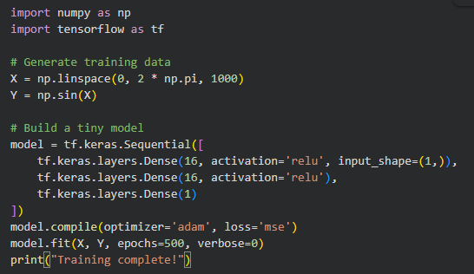
- Step 2 — Convert to Quantized TFLite Model
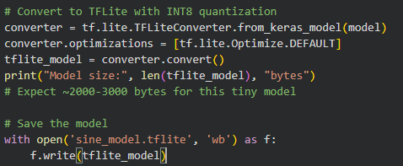
- Step 3 — Convert .tflite to a C Header File
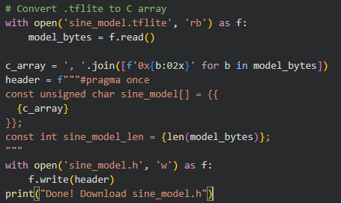
- Step 4 — Deploy and Run Inference (Arduino / ESP32)
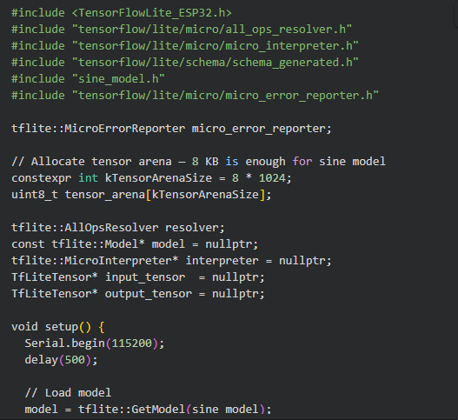
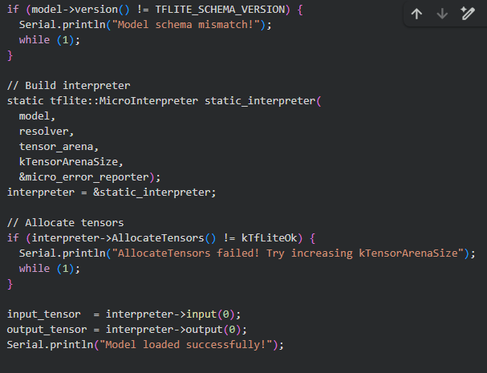
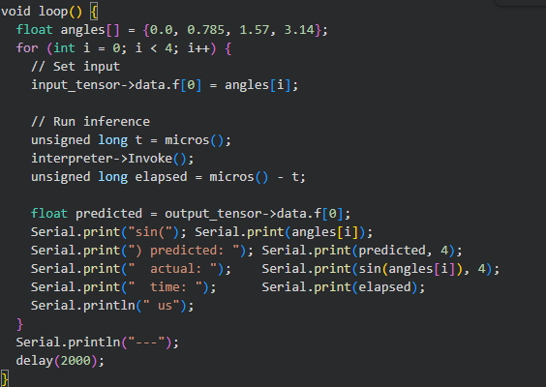

OUTPUT OF TASK 01:
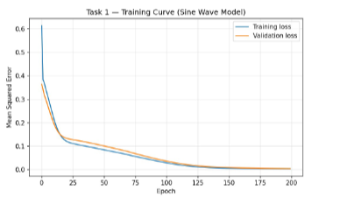
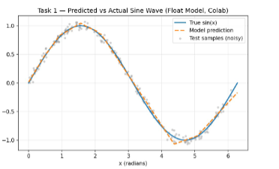
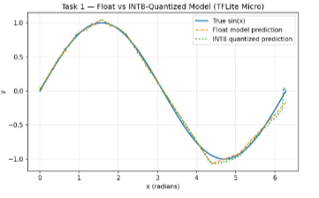

TASK: 02
CODE:
- Step 1 — Record Normal Sensor Data (Arduino, run once)
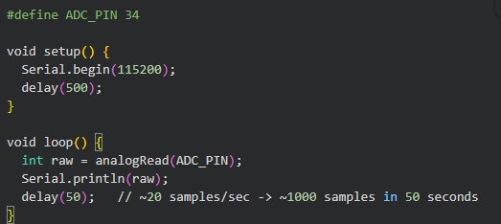
- Step 2 — Train the Autoencoder (Google Colab / Python)
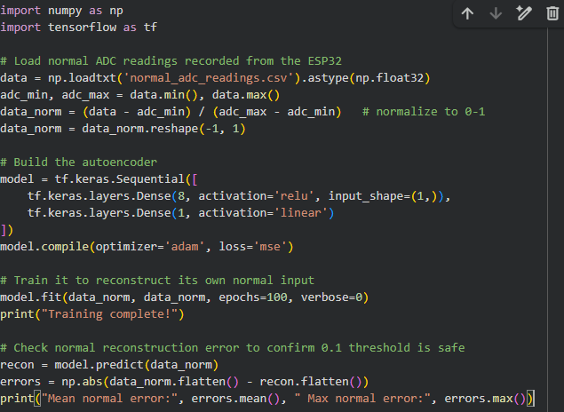
- Step 3 — Convert to TFLite Model
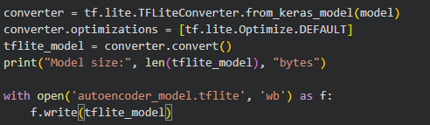
- Step 4 — Convert .tflite to a C Header File
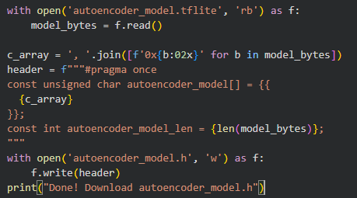
- Step 5 — Deploy: Detect Anomalies and Trigger LED (Arduino / ESP32)
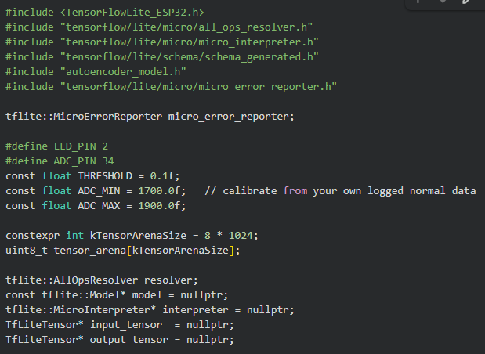
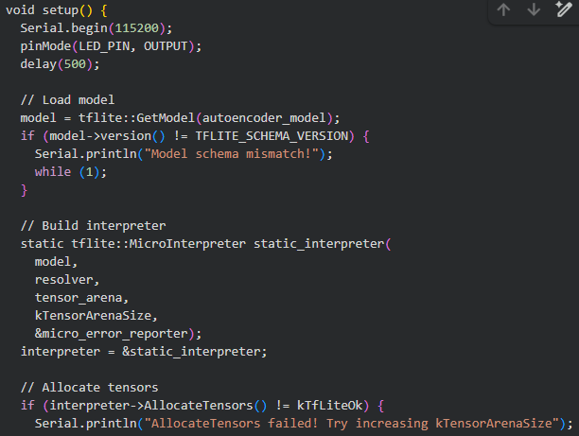
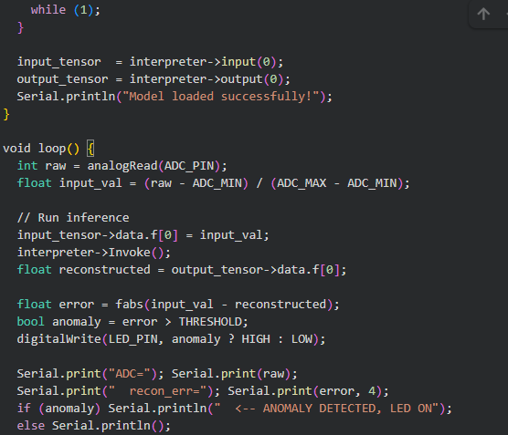
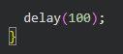

OUTPUT OF TASK 02:
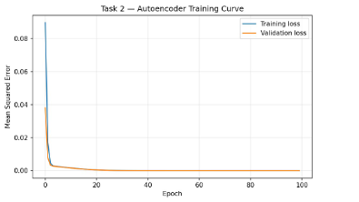
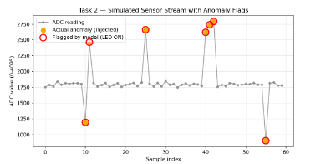
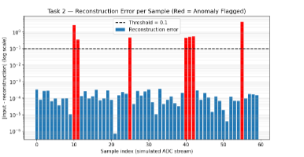
CONCLUSION:
This lab demonstrated the complete edge-AI deployment pipeline, from training a model in Colab to running quantized inference on an ESP32. Task 1 showed accurate sine wave prediction using a regression model, while Task 2 used an autoencoder to successfully detect anomalies via reconstruction error. Together, they confirmed that even resource-constrained microcontrollers can run real-time ML inference effectively.

